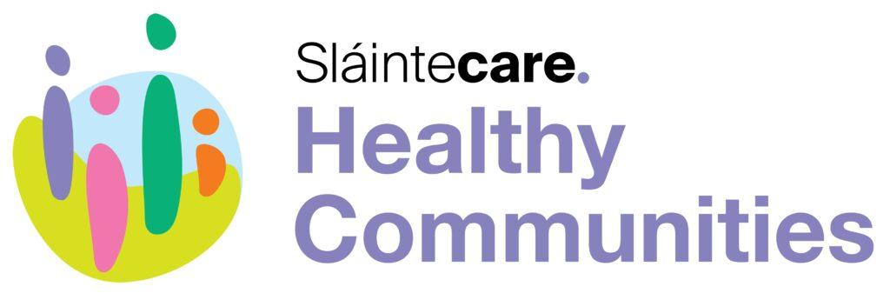
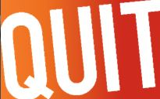

Get the support you need to quit for good.
We Can Quit is a free group programme for people who want support to quit smoking.
The programme runs for 7 to 12 weeks and offers you free stop smoking medication, a weekly stop smoking group, and 1-1 support. You get support to quit from a local facilitator, people in your group and a local pharmacist.

You are 5 times more likely to quit for good if you:
- commit to quit for 28 days
- get support to change your behaviour
- use stop smoking medicines

We Can Quit is offered by the HSE in partnership with Clonmel CRC.
Location: Clonmel Community Resource Centre, Kickham Street, E91 P2N5
Dates: 20th March, 27th March, 3rd April, 10th April, 17th April, 24th April and 1st May
Time: 7:00pm to 8:30pm

Registration for the programme is now open in Clonmel. For further Details please
Contact: Geraldine Moloney (087 1880690) Contact: Catherine Murphy
Email: Geraldine.Moloney@hse.ie Email: Healthycommunities@clonmelcrc.ie
